**Complexity Analysis:**

**Consider the following example from the test file in which we sorted and applied searching on Float Data Type:**

**Sorting Analysis:**

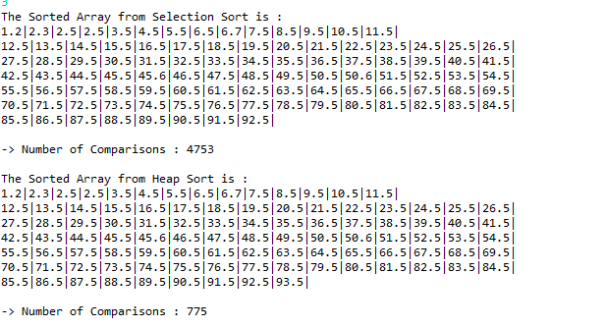

**Here we have used Selection Sort from O(N2) algos and Heap Sort from O(NLogN2)**

**The size of float array is 98, O(N2)=9604, O(LogN2)=646 ~ 775. so the Heap sort performed efficiently compared to Selection Sort.**

**Searching analysis:**

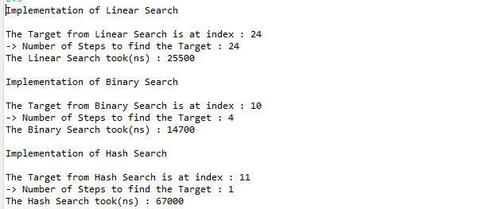

**Linear Search:**

**Linear Search took 24 steps which is O(n) to find the Target**

**Binary Search tool 4 steps to find target O(log98)~6.6**

**Hash Search took 1 step i.e, O(1) Search can be achieved in other case it will provide linearly but in less number of steps than Linear Search**